Urdf Ankle yaw

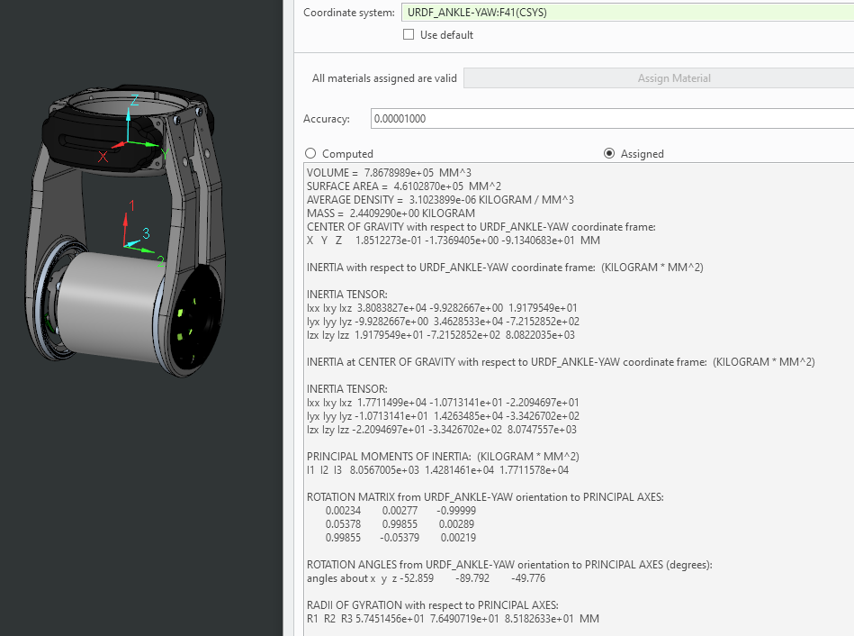

VOLUME = 7.8678989e+05 MM^3

SURFACE AREA = 4.6102870e+05 MM^2

AVERAGE DENSITY = 3.1023899e-06 KILOGRAM / MM^3

MASS = 2.4409290e+00 KILOGRAM

CENTER OF GRAVITY with respect to URDF_ANKLE-YAW coordinate frame:

X Y Z 1.8512273e-01 -1.7369405e+00 -9.1340683e+01 MM

INERTIA with respect to URDF_ANKLE-YAW coordinate frame: (KILOGRAM * MM^2)

INERTIA TENSOR:

Ixx Ixy Ixz 3.8083827e+04 -9.9282667e+00 1.9179549e+01

Iyx Iyy Iyz -9.9282667e+00 3.4628533e+04 -7.2152852e+02

Izx Izy Izz 1.9179549e+01 -7.2152852e+02 8.0822035e+03

INERTIA at CENTER OF GRAVITY with respect to URDF_ANKLE-YAW coordinate frame: (KILOGRAM * MM^2)

INERTIA TENSOR:

Ixx Ixy Ixz 1.7711499e+04 -1.0713141e+01 -2.2094697e+01

Iyx Iyy Iyz -1.0713141e+01 1.4263485e+04 -3.3426702e+02

Izx Izy Izz -2.2094697e+01 -3.3426702e+02 8.0747557e+03

PRINCIPAL MOMENTS OF INERTIA: (KILOGRAM * MM^2)

I1 I2 I3 8.0567005e+03 1.4281461e+04 1.7711578e+04

ROTATION MATRIX from URDF_ANKLE-YAW orientation to PRINCIPAL AXES:

0.00234 0.00277 -0.99999

0.05378 0.99855 0.00289

0.99855 -0.05379 0.00219

ROTATION ANGLES from URDF_ANKLE-YAW orientation to PRINCIPAL AXES (degrees):

angles about x y z -52.859 -89.792 -49.776

RADII OF GYRATION with respect to PRINCIPAL AXES:

R1 R2 R3 5.7451456e+01 7.6490719e+01 8.5182633e+01 MM

Urdf WHEEL23

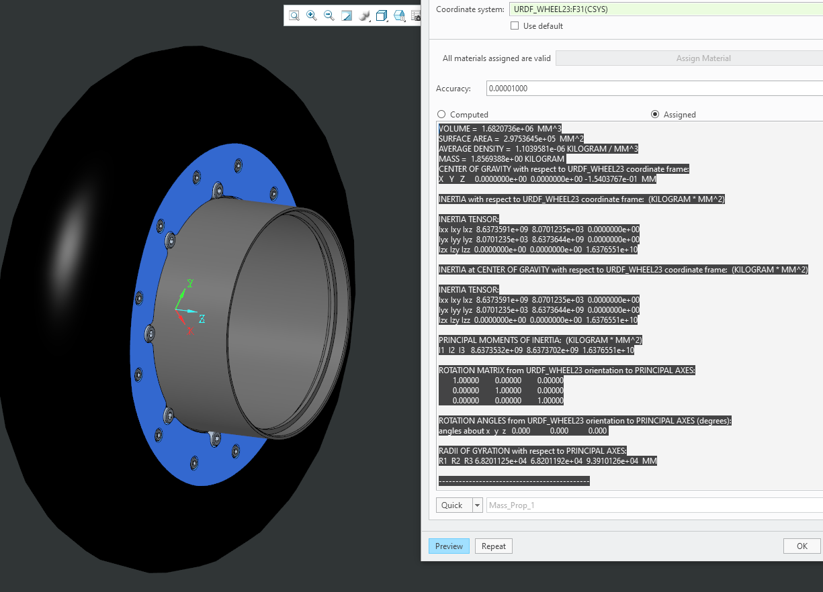

VOLUME = 1.6820736e+06 MM^3

SURFACE AREA = 2.9753645e+05 MM^2

AVERAGE DENSITY = 1.1039581e-06 KILOGRAM / MM^3

MASS = 1.8569388e+00 KILOGRAM

CENTER OF GRAVITY with respect to URDF_WHEEL23 coordinate frame:

X Y Z 0.0000000e+00 0.0000000e+00 -1.5403767e-01 MM

INERTIA with respect to URDF_WHEEL23 coordinate frame: (KILOGRAM * MM^2)

INERTIA TENSOR:

Ixx Ixy Ixz 8.6373591e+09 8.0701235e+03 0.0000000e+00

Iyx Iyy Iyz 8.0701235e+03 8.6373644e+09 0.0000000e+00

Izx Izy Izz 0.0000000e+00 0.0000000e+00 1.6376551e+10

INERTIA at CENTER OF GRAVITY with respect to URDF_WHEEL23 coordinate frame: (KILOGRAM * MM^2)

INERTIA TENSOR:

Ixx Ixy Ixz 8.6373591e+09 8.0701235e+03 0.0000000e+00

Iyx Iyy Iyz 8.0701235e+03 8.6373644e+09 0.0000000e+00

Izx Izy Izz 0.0000000e+00 0.0000000e+00 1.6376551e+10

PRINCIPAL MOMENTS OF INERTIA: (KILOGRAM * MM^2)

I1 I2 I3 8.6373532e+09 8.6373702e+09 1.6376551e+10

ROTATION MATRIX from URDF_WHEEL23 orientation to PRINCIPAL AXES:

1.00000 0.00000 0.00000

0.00000 1.00000 0.00000

0.00000 0.00000 1.00000

ROTATION ANGLES from URDF_WHEEL23 orientation to PRINCIPAL AXES (degrees):

angles about x y z 0.000 0.000 0.000

RADII OF GYRATION with respect to PRINCIPAL AXES:

R1 R2 R3 6.8201125e+04 6.8201192e+04 9.3910126e+04 MM

T-matrix ankle yaw – wheel 23

